***COMP9331/3331 Lab01***

**Exercise 1: nslookup**

**Q1)** Which is the IP address of the CNN website ( [www.cnn.com](http://www.cnn.com/))? In your opinion, what is the reason of having several IP addresses as an output?

Server: 129.94.0.196

Address: 129.94.0.196#53

Non-authoritative answer:

Name: cnn.com

Address: 151.101.65.67

Name: cnn.com

Address: 151.101.129.67

Name: cnn.com

Address: 151.101.1.67

Name: cnn.com

Address: 151.101.193.67

The reason for having multiple IP addresses is to compensate for hosts that are down at particular moments. This prevents traffic from being exchanged at the gateway, reducing the load and allowing for greater speeds

**Q2)** Find out name of the IP address 127.0.0.1. What is special about this IP address?

Server: 129.94.0.196

Address: 129.94.0.196#53

1.0.0.127.in-addr.arpa name = localhost.

This IP address is the local host. ‘localhost’ is the internal interface of the machine so it sends a packet to itself. This is the IP of every PC which is 127.0.0.1

**Exercise 2: Using ping to test host reachability**

[www.unsw.edu.au](http://www.unsw.edu.au)

* Reachable using ping

[www.getfittest.com.au](http://www.getfittest.com.au)

* Not reached
* Server probably doesn’t exist as it is unknown when checking with nslookup. Can’t access on web browser either

[www.mit.edu](http://www.mit.edu)

* Reachable

[www.intel.com.au](http://www.intel.com.au)

* Reachable

[www.tpg.com.au](http://www.tpg.com.au)

* Reachable

[www.hola.hp](http://www.hola.hp)

* Not reachable
* Server probably doesn’t exist as it is unknown when checking with nslookup. Can’t access on web browser either

[www.amazon.com](http://www.amazon.com)

* Reachable

[www.tsinghua.edu.cn](http://www.tsinghua.edu.cn)

* Reachable

[www.kremlin.ru](http://www.kremlin.ru)

* Requests for ping keep timing out. However, it is accessible by web browser and exists when checking through nslookup. This site could have blocked ping access at the firewall level to prevent DoS attacks. It may

8.8.8.8

* Reachable by ping

**Exercise 3: Use traceroute to understand network topology**

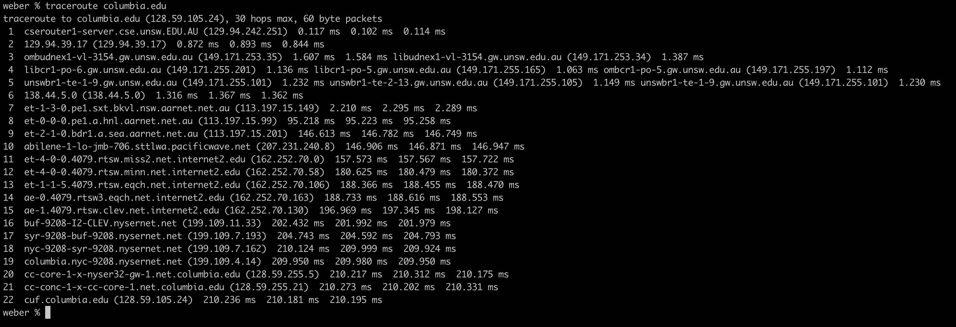**Q1)** Run traceroute on your machine to [www.columbia.edu](http://www.columbia.edu/). How many routers are there between your workstation and[www.columbia.edu](http://www.columbia.edu/)? How many routers along the path are part of the UNSW network? Between which two routers do packets cross the Pacific Ocean? Hint: compare the round trip times from your machine to the routers using ping.

As shown above, there are 22 routers between my workstation and [www.columbia.edu](http://www.columbia.edu).

There are 4 routers that contain the string ‘unsw’. The second router belongs to the Australian academic and Research network which is also a part of UNSW. So there are 5 UNSW routers along the route.

The round trip times from the 7th router is about 2ms while the 8th is about 95ms. This massive jump in time is a good indicator that the packets cross the pacific ocean between routers 7 and 8

**Q2)** Run traceroute from your machine to the following destinations:(i) [www.ucla.edu](http://www.ucla.edu/)(ii) [www.u-tokyo.ac.jp](http://www.u-tokyo.ac.jp/)and (iii)[www.lancaster.ac.uk](http://www.lancaster.ac.uk/). At which router do the paths from your machine to these three destinations diverge? Find out further details about this router. (HINT: You can find out more about a router by running the whois command: whois router-IP-address). Is the number of hops on each path proportional the physical distance? HINT: You can find out geographical location of a server using the following tool - <http://www.yougetsignal.com/tools/network-location/>

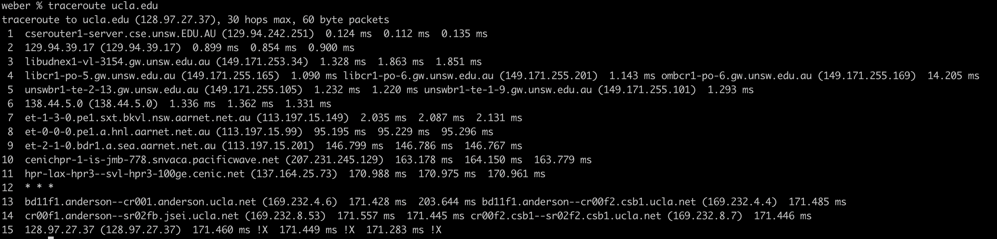

UCLA traceroute above

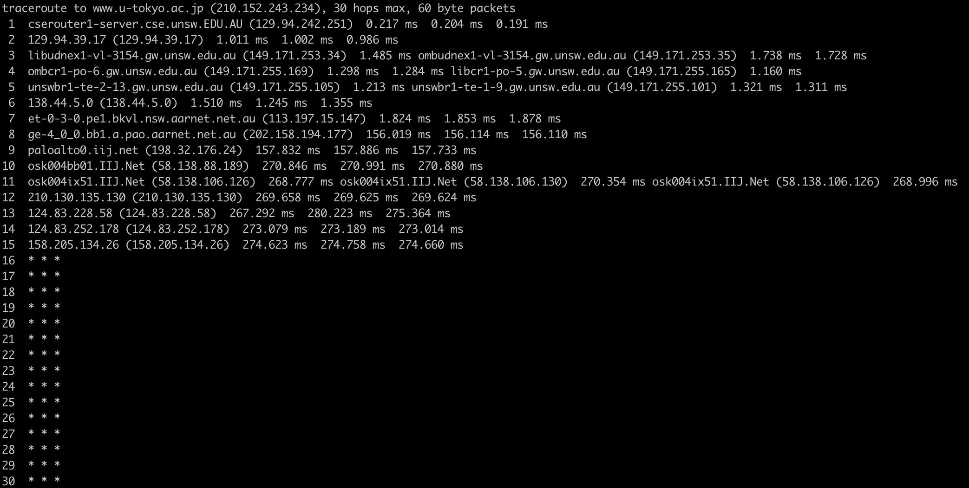

U-tokyo traceroute above

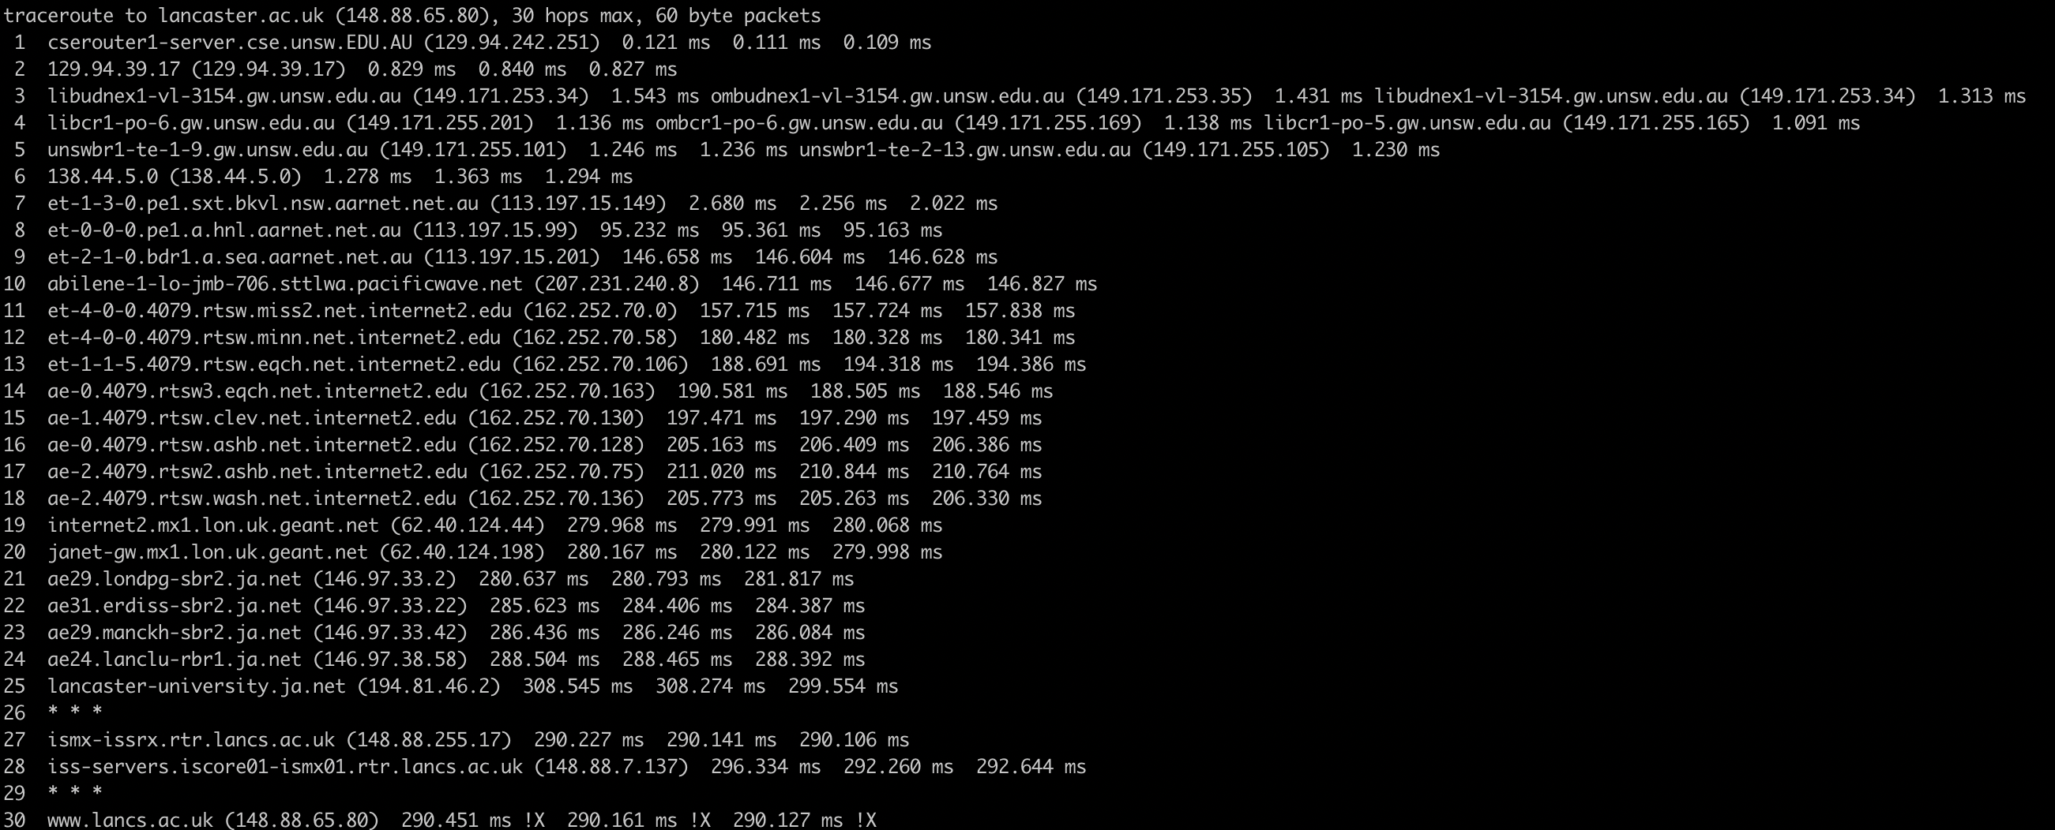

Lancaster traceroute above

The paths to the different addresses diverge on the router with the address 138.44.5.0. The router is run by the Asia Pacific Network Information Centre (APNIC).

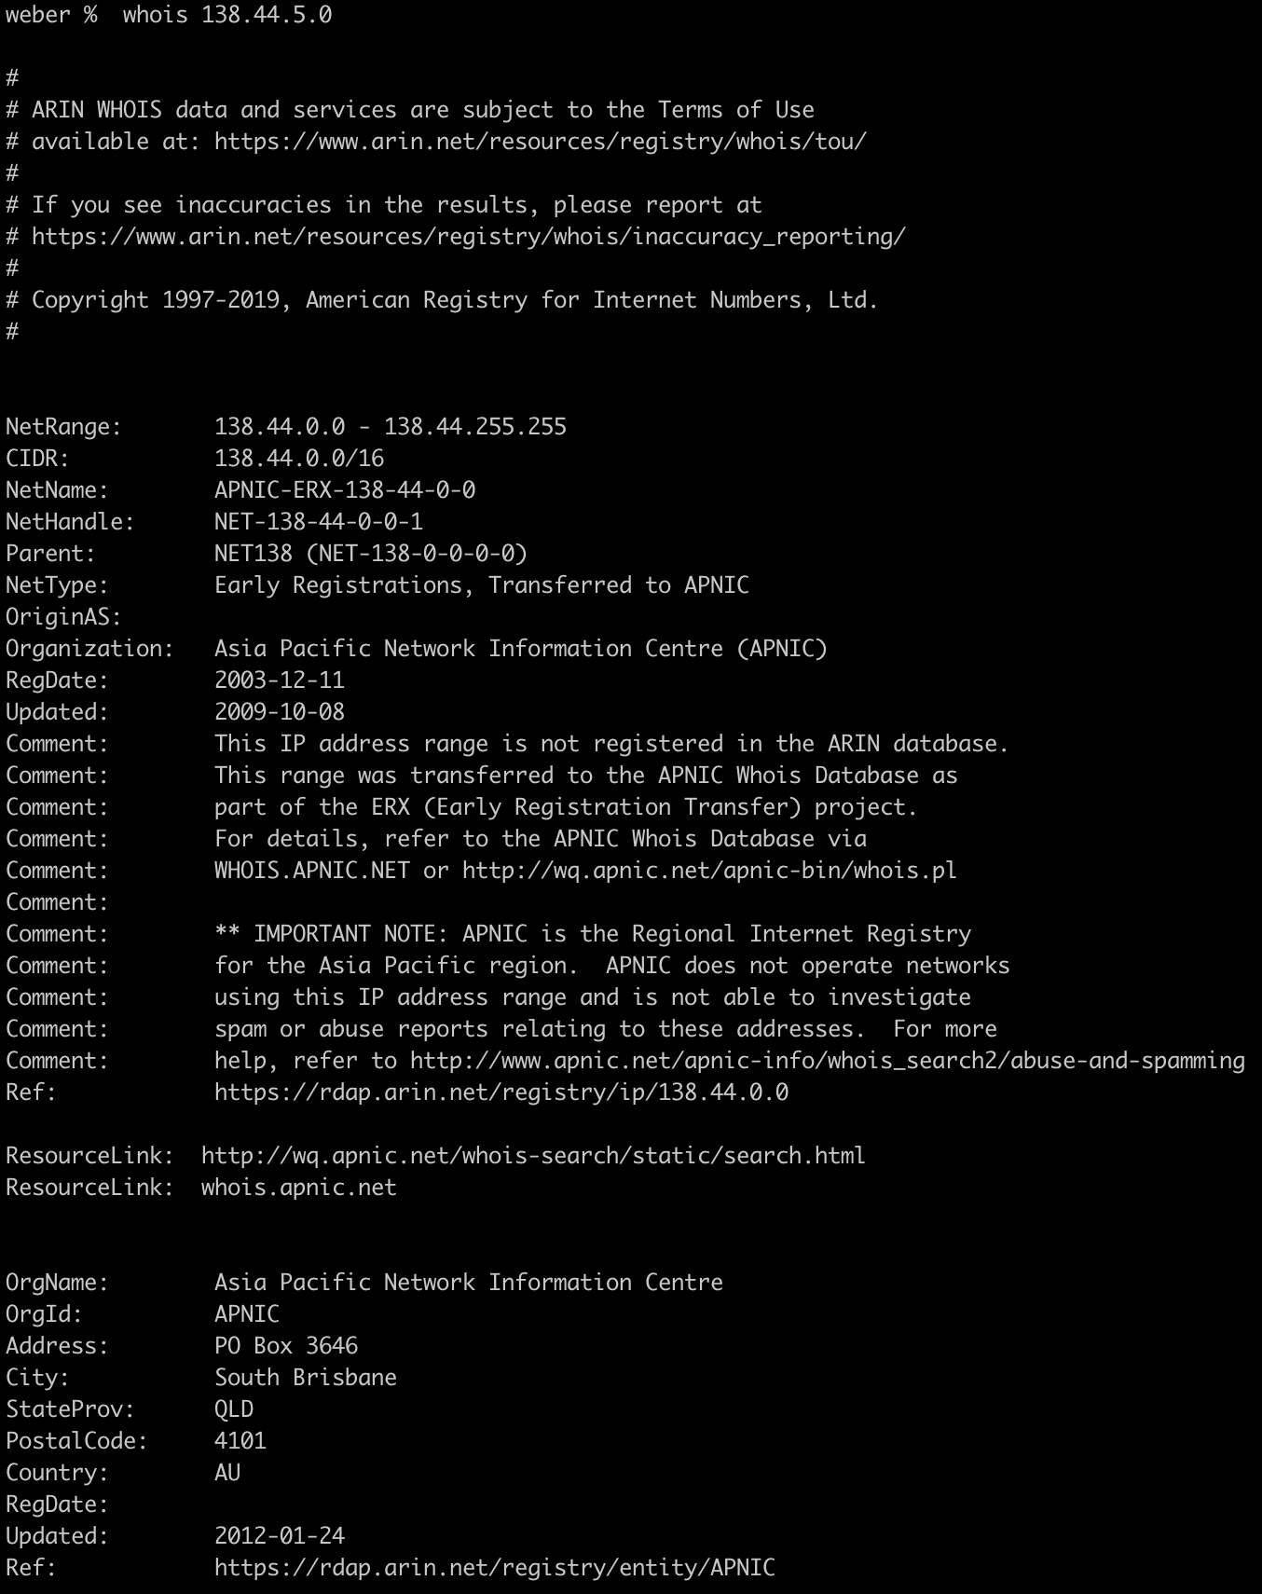

The distance to [www.ucla.edu](http://www.ucla.edu) is about **7499.00 miles** and there are 15 hops

The distance to  [www.u-tokyo.ac.jp](http://www.u-tokyo.ac.jp/) is about **5558.0 miles**  and there are 15 hops

The distance to [www.lancaster.ac.uk](http://www.lancaster.ac.uk/) is about **5797.1 miles** and there are 26 hops

Therefore it can be concluded that the number of hops is not proportional to physical distance

**Q3)** Several servers distributed around the world provide a web interface from which you can perform a traceroute to any other host in the Internet. Here are two examples: (i) <http://www.speedtest.com.sg/tr.php>and (ii) <https://www.telstra.net/cgi-bin/trace>. Run traceroute from both these servers towards your machine and in the reverse direction (i.e. from your machine to these servers). You may also try other traceroute servers from the list at [www.traceroute.org](http://www.traceroute.org/). What are the IP addresses of the two servers that you have chosen. Does the reverse path go through the same routers as the forward path? If you observe common routers between the forward and the reverse path, do you also observe the same IP addresses? Why or why not?

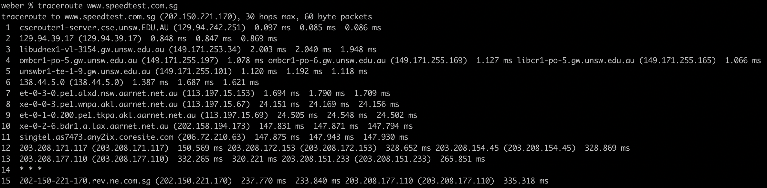

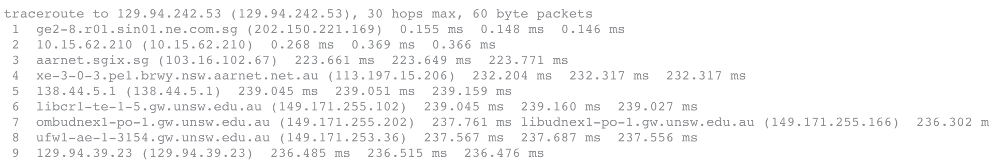

Above are the traceroute results between my IP and speedtest.com.sg

The IP address of speedtest.com is 202.150.221.170.

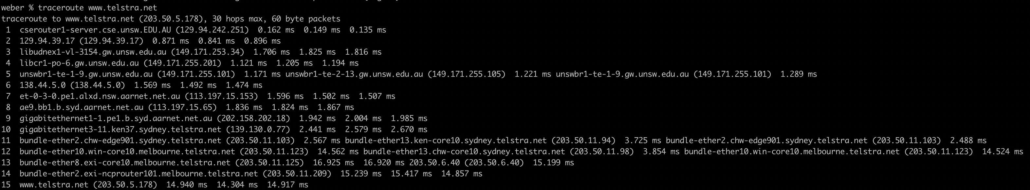

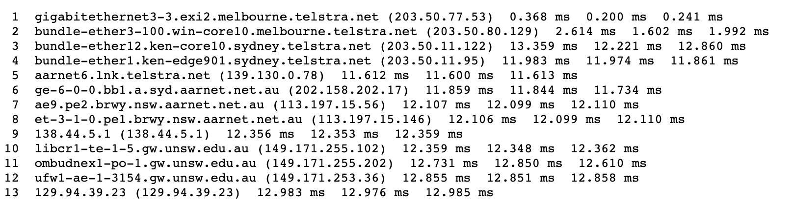

Above are the traceroute results between my IP and telstra.net

The IP of telstra.net is 203.50.5.178

For both cases, the paths between the two servers are NOT the same. However, the path between telstra is quite similar. There are common routers but they have different IP addresses. This is because they have different interfaces. So traffic going from A🡪B will use a different interface from traffic moving from B🡪A. This results in the same routers giving different IP addresses.

**Exercise 4: Use ping to gain insights into network performance**

**Q1)**

The approximate distance between UNSW and UQ is about 733km. Therefore, the shortest possible time T is T = 933km / 3 x 108 = 2.443ms. The value of the y-axis is 16.723 / 2.443 = 6.873

The approximate distance between UNSW and Beijing(Tsinghua University) is 8948km. Therefore, the shortest possible time T is T = 8948km / 3 x 108 = 29.826ms. The value of the y-axis is 274.64 / 29.826 = 5.723

The approximate distance between UNSW and Berlin is 16117km. Therefore, the shortest possible time T is T = 16117km / 3 x 108 = 53.723ms. The value of the y-axis is 307.488 / 53.723 = 5.723

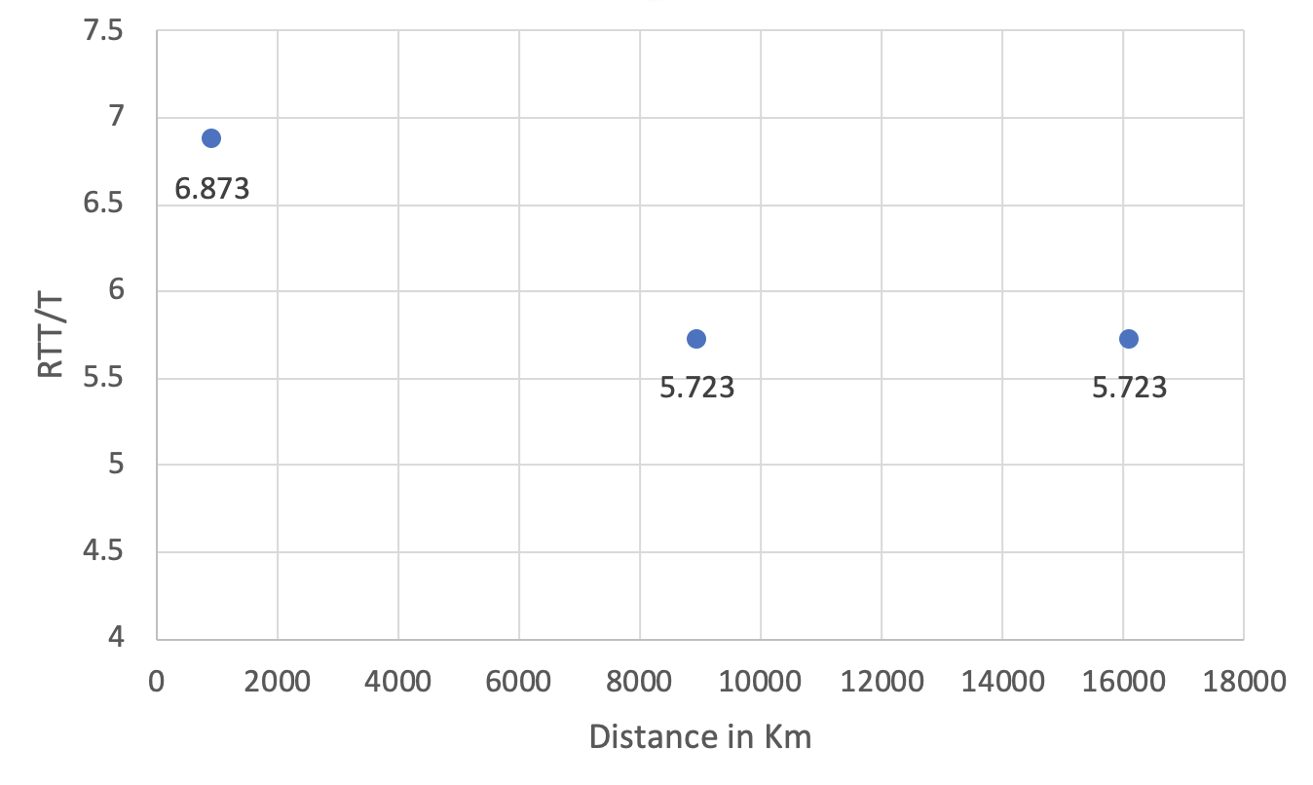

The RTT/T ratio being greater than 2 can be attributed to a variety of reasons. Some of these can be due to congestion or interference along the route between my computer and the destination server. It should also be noted that most long distance internet cables cannot carry signals at the speed of light due to refraction, meaning it will be unable to match the minimum time T which assumes light speed travel.

**Q2) Is the delay to the destinations constant or does it vary over time? Explain why.**

[www.uq.com](http://www.uq.com)

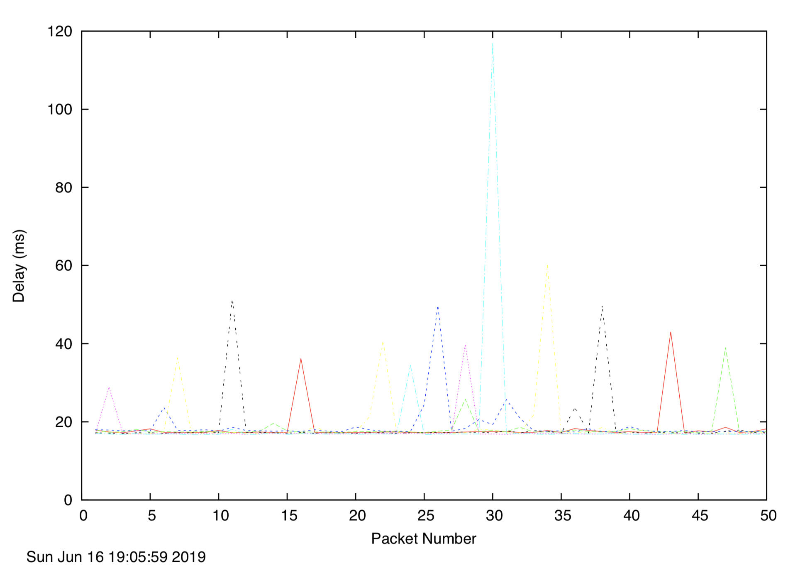

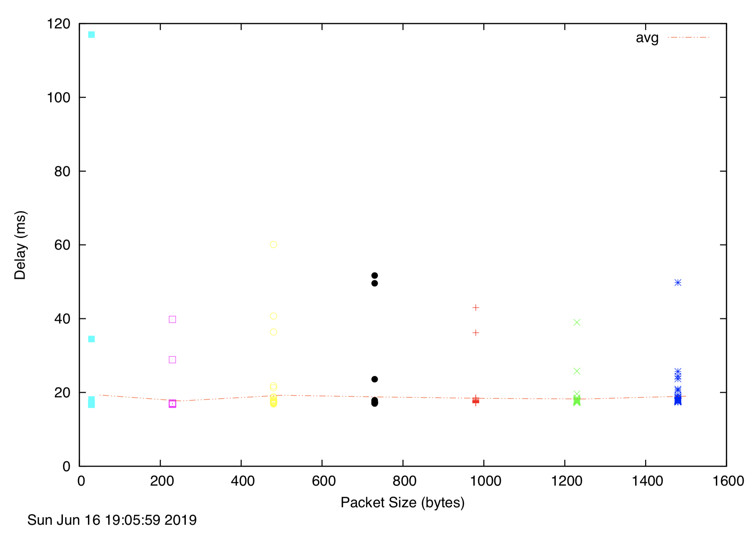

[www.tsinghua.edu.cn](http://www.tsinghua.edu.cn)

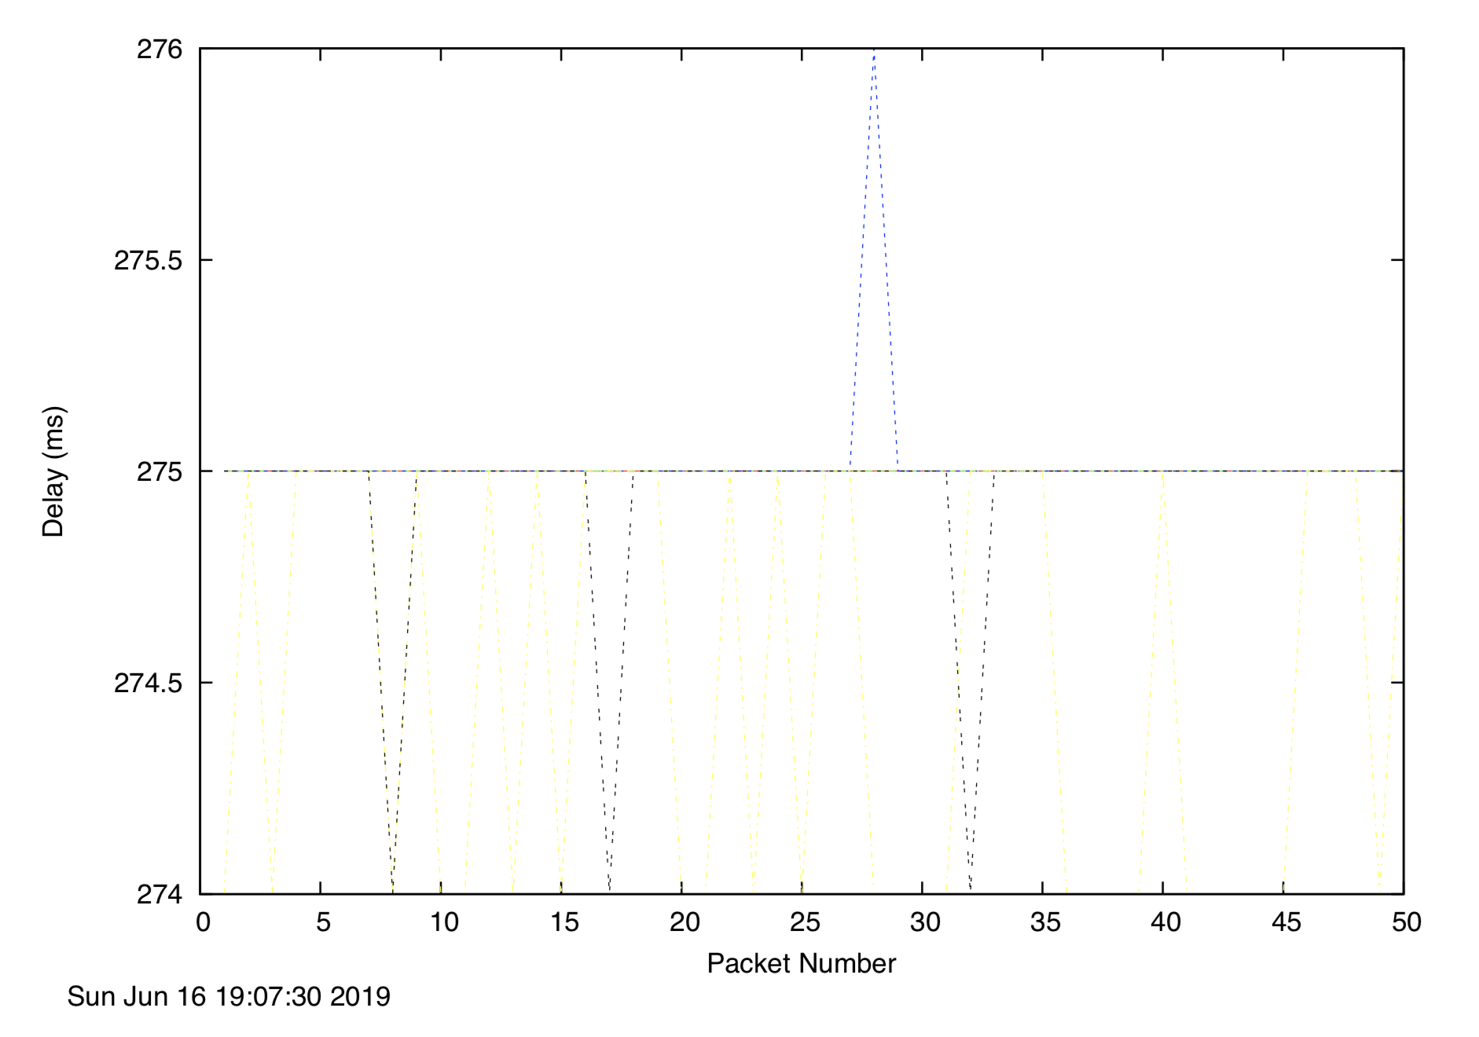

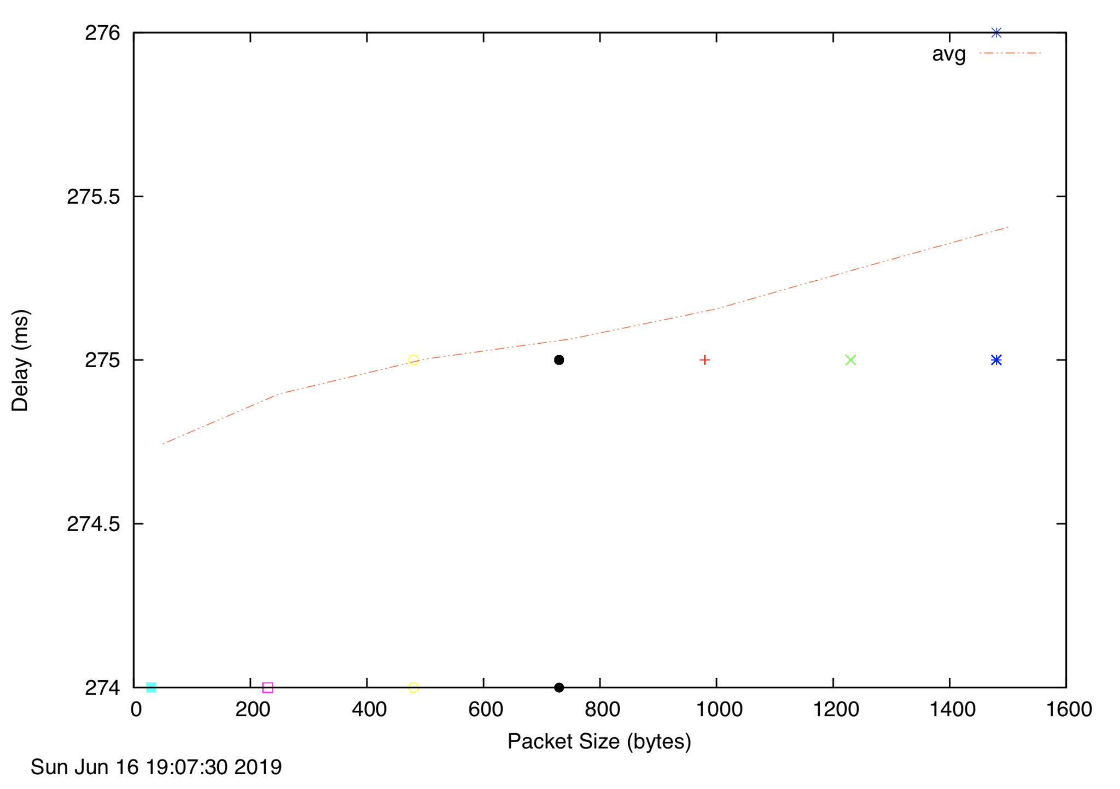

[www.tu-berlin.de](http://www.tu-berlin.de)

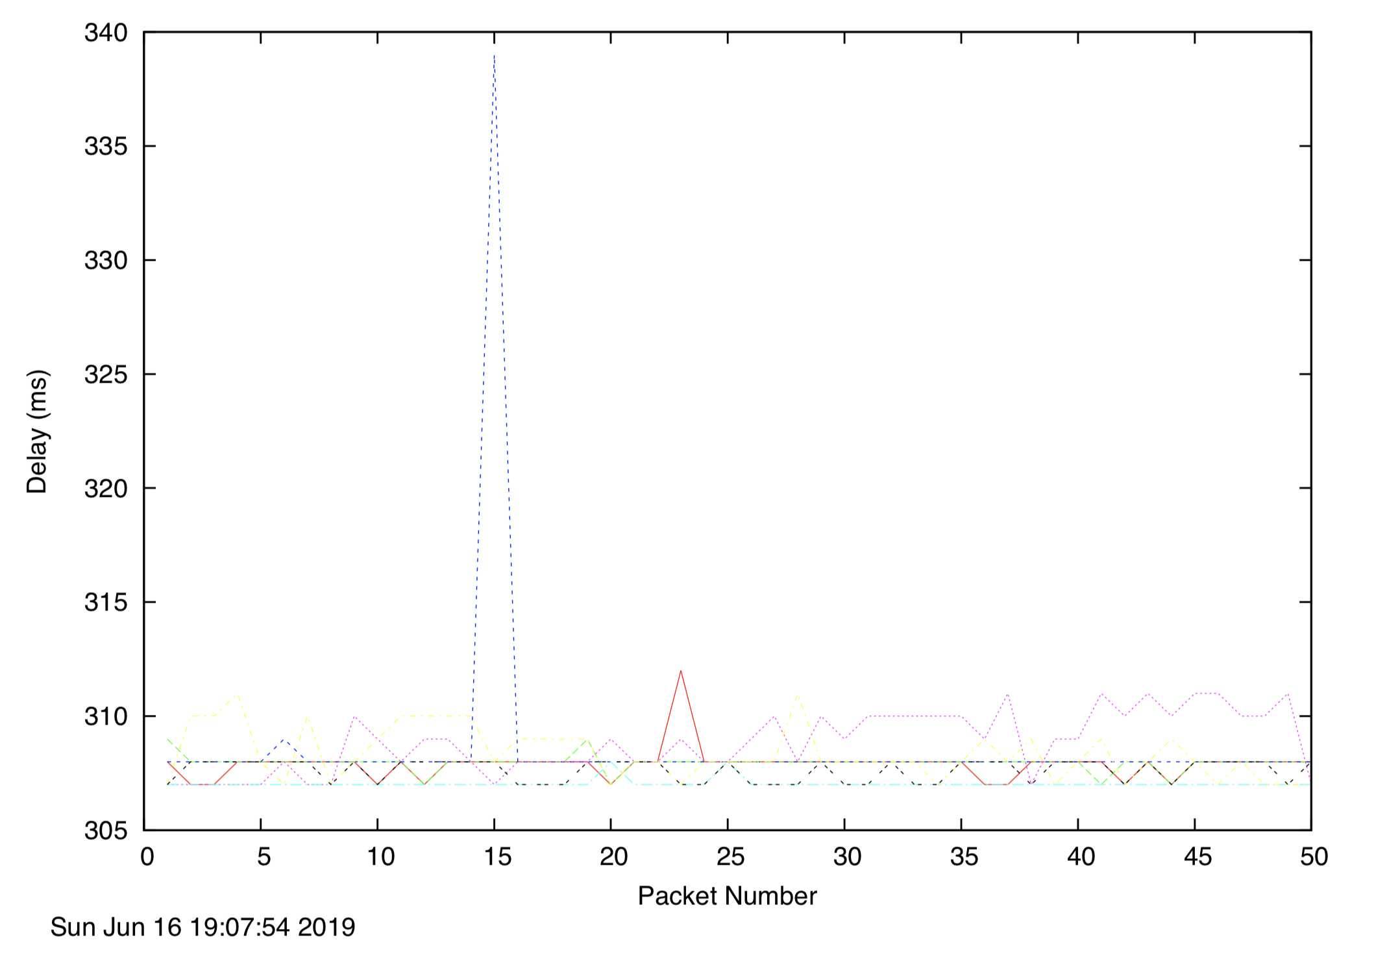

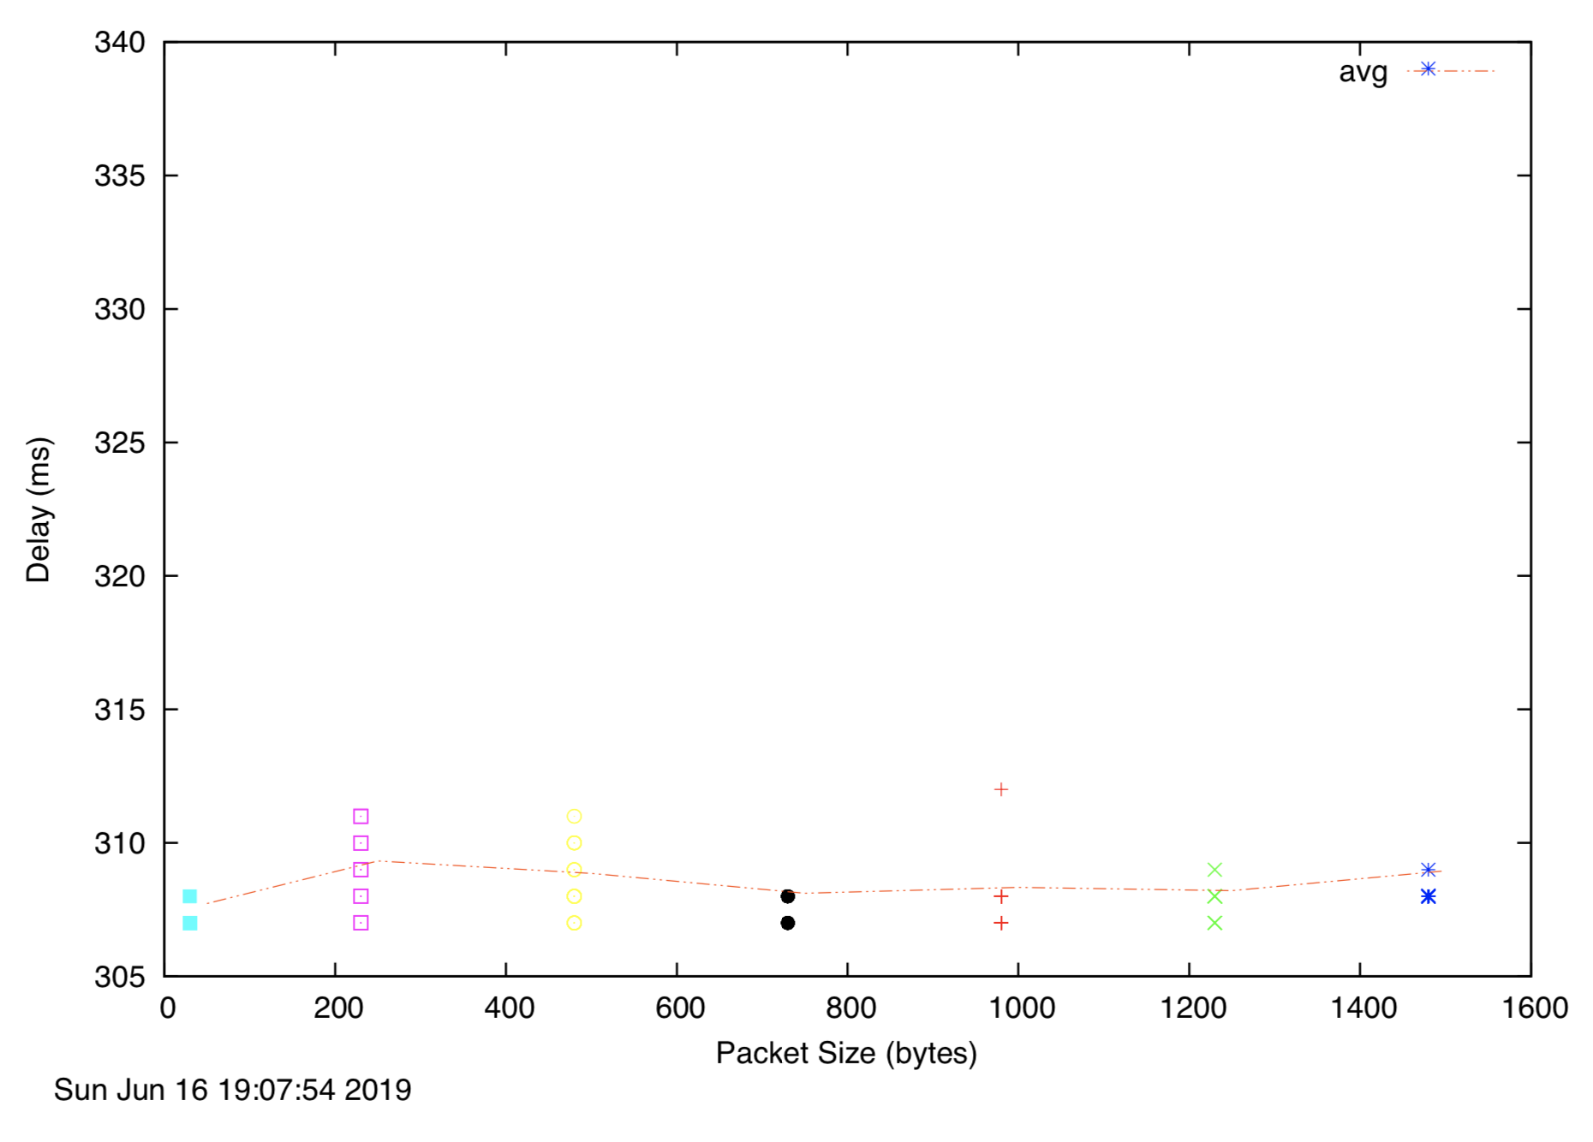

According to the graphs above, delay to the destinations tend to be constant over time, with the exception of a few bursts of delay every now and then. This is due to the use of Packet switching, resulting in resource flow to be dynamically allocated. Therefore, no overloading occurs

**Q3) Explore where the website for**[**www.epfl.ch**](http://www.epfl.ch/)**is hosted. Is it in Switzerland?**

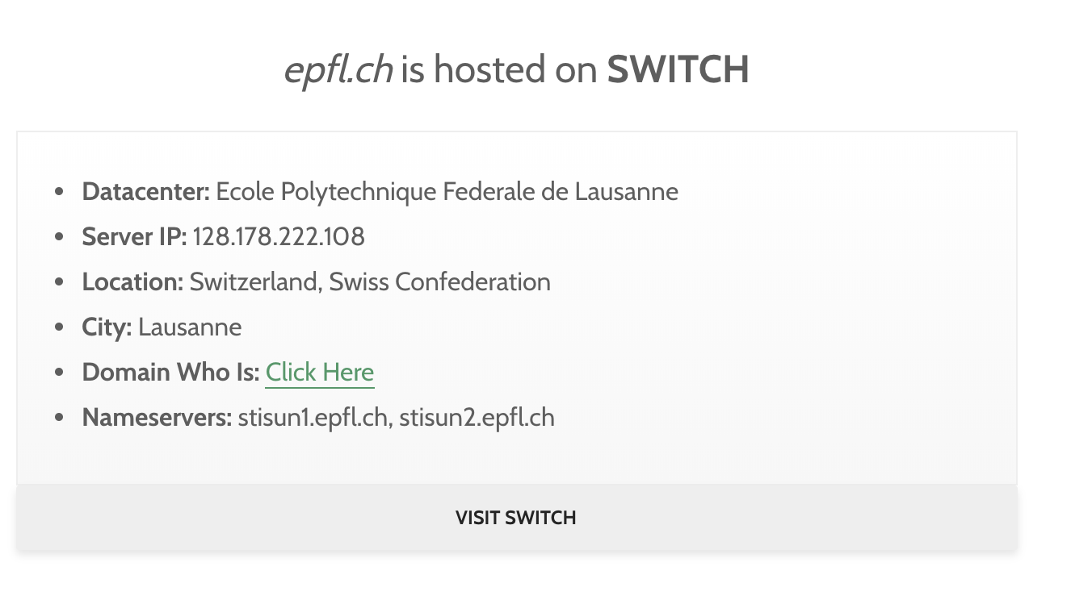

It appears that epfl.ch is indeed hosted in Switzerland.

**Q4) The measured delay (i.e., the delay you can see in the graphs) is composed of propagation delay, transmission delay, processing delay and queuing delay. Which of these delays depend on the packet size and which do not?**

Only **Transmission Delay** depends on packet size. It is the amount of time required to transmit an entire packet of a certain size. The formula to calculate Transmission delay is L/R, where L = packet size and R = Bandwidth.

**None of the other delays** depend on packet size. Propagation depends on the length of the physical link (i.e. distance). Processing delay is the time it takes routers to process the packet header. Queuing delay is the amount of time that the packet has to wait at the output link.